ARINC 429 Data Bus Final Report

Caterpillar

Brandon Tiet, Joshua French, Elnatan Belay

CYSE 465-001 Fall 2025

December 11th, 2025

Abstract
Our team conducted a security audit of the ARINC 429 protocol. During this audit we found that this protocol relies completely on its hardwired nature, and obscurity as security methods to prevent potential attackers. Our team simulated the protocol as is over VCAN, three attacks against it including Spoofing, Replay, and DoS, and finally implemented solutions to prevent these style of attacks against the system. This report details how the current system works, how our selected attacks work against the system, and our recommendations to improve the protocol.

All code can be found in our group's Git repository at https://github.com/JoshuaMFrench/CYSE465-Caterpillars-Group/tree/main

Introduction
The domain that this paper will be on, is in the Aviation domain, and the protocol that we are going to be focusing on is the ARINC 429 data bus. Our paper will plan to address the threat vectors to the data bus and resolve them by implementing a security gateway at the receiving data bus so that any information that is sent must have the correct keys. This protocol is paramount because it handles all the communication within the plane and any of the data being transmitted across the plane. Whether that be the flight information at that moment to the black box, or the radar data that is being displayed could not be visible on the screen in the cockpit.

System Architecture and Design
The Scope of the project includes simulating the databus by sending correctly formatted data from one system to another. Simulating an attack on an identified "Vulnerable system” or assuming an attack on the airbus via physical access, insider threat, or supply chain, and using the databus to send malicious messages to another system on the plane. The hardening process will include applying a filtering technique to the data bus to allow it to ignore potentially malicious frames sent over the bus.

The Arinc Protocol works by having one transmitter send a 32 bit message to up to 20 different receivers in the order displayed in the image below. All communications run on a twisted pair wire running at 12.5 or 100 kHz, one one of these data rates may be used in a system not both.

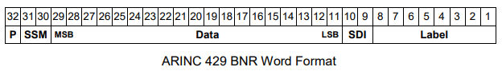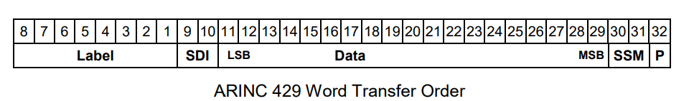

The requirements for the ARINC 429 airbus protocol requires that all data, called frames or words, is formatted in 32 bit and consists of an 8 bit label that contains context for the data (e.g. elevation data, velocity data, radar data), a 2 bit SDI that contains information about the receiving data sink, 19 bits of data, a 2 bit SSM that contains additional information depending on the label (ex negative or positive, cardinal direction), and a 1 bit P value that ensures the total number of ones is odd if there is no error in transmission, or even if there is an error. Additionally the protocol calls for one way communications

In our research we decided to add three main defenses to the ARINC protocol, HMAC encryption, NONCE, and gateway. Before each message is sent it will be hashed using the HMAC protocol and a shared key, allowing the receiver to use the key to unhash it verifying its integrity. Additionally, before being hashed, it will be assigned a number only used once (NONCE). This number will come in the form of a new 8 bit field added to the front, and the receiver will check to see if that number has been used yet. This ensures that replay attacks are blocked. Finally, we want to implement a gateway that would enforce rate limits so that if a sender is forwarding too many packets within a certain time frame, then those packets get dropped from that sender. This gateway would also create a buffer which would ensure the timings for the data is correct and accurate, or else the packets would be dropped by the receiver.
SysML Diagram

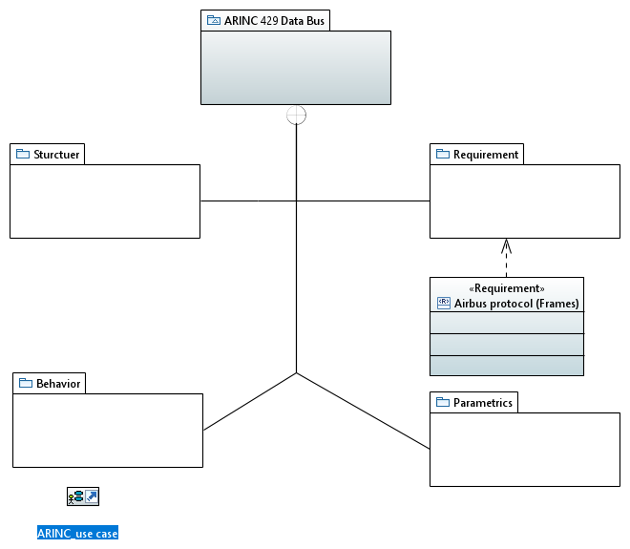
Figure 1: Package Diagram
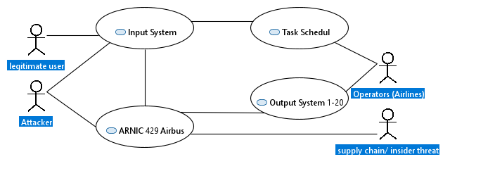
Figure 2: Use Case Diagram

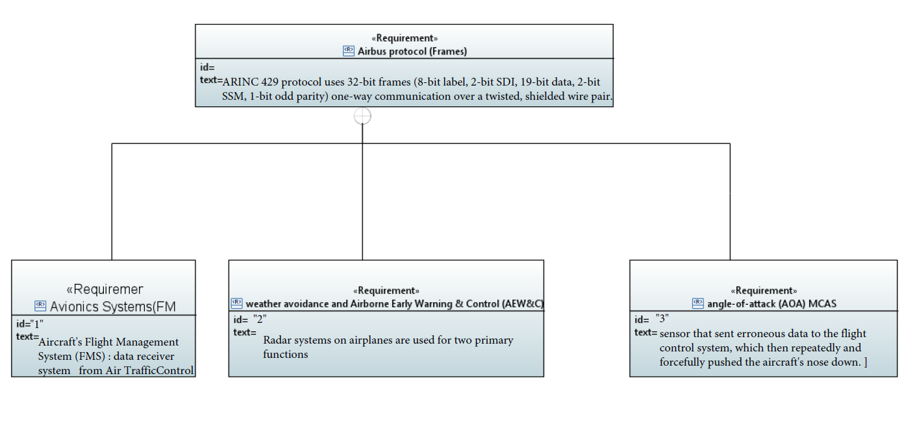
Figure 3: Requirements Diagram
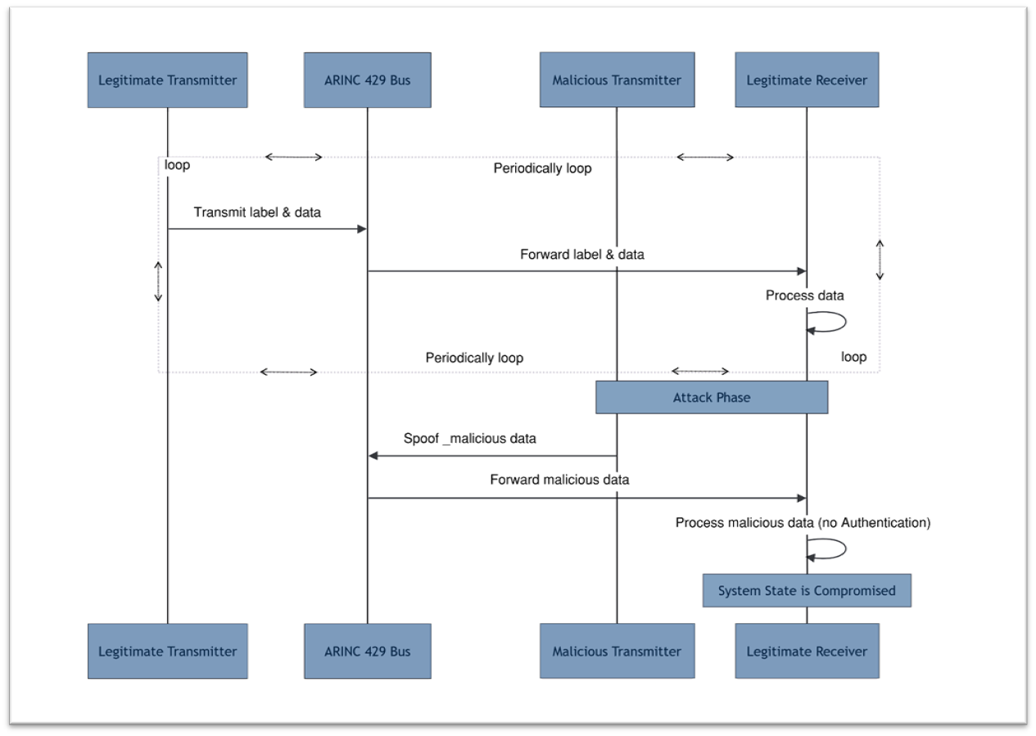
Figure 4: Spoofing Attack
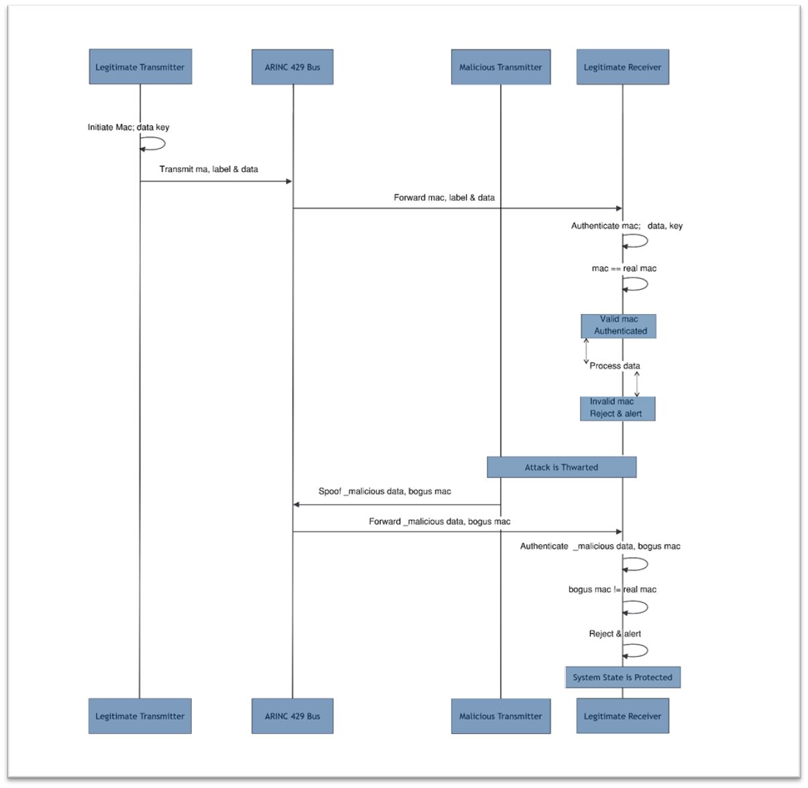
Figure 5: Spoofing Defense
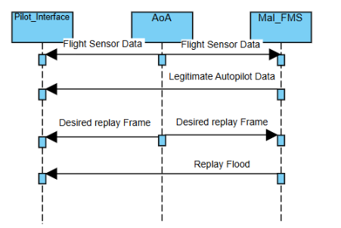

Figure 6: Replay Attack
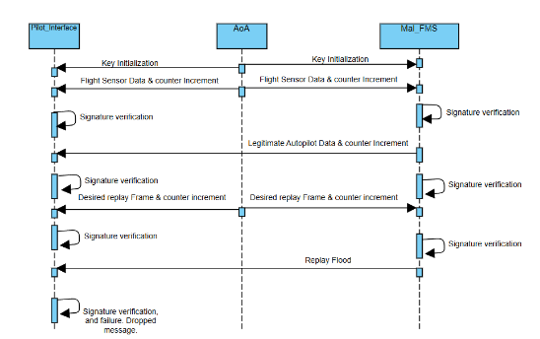

Figure 7: Replay Defense
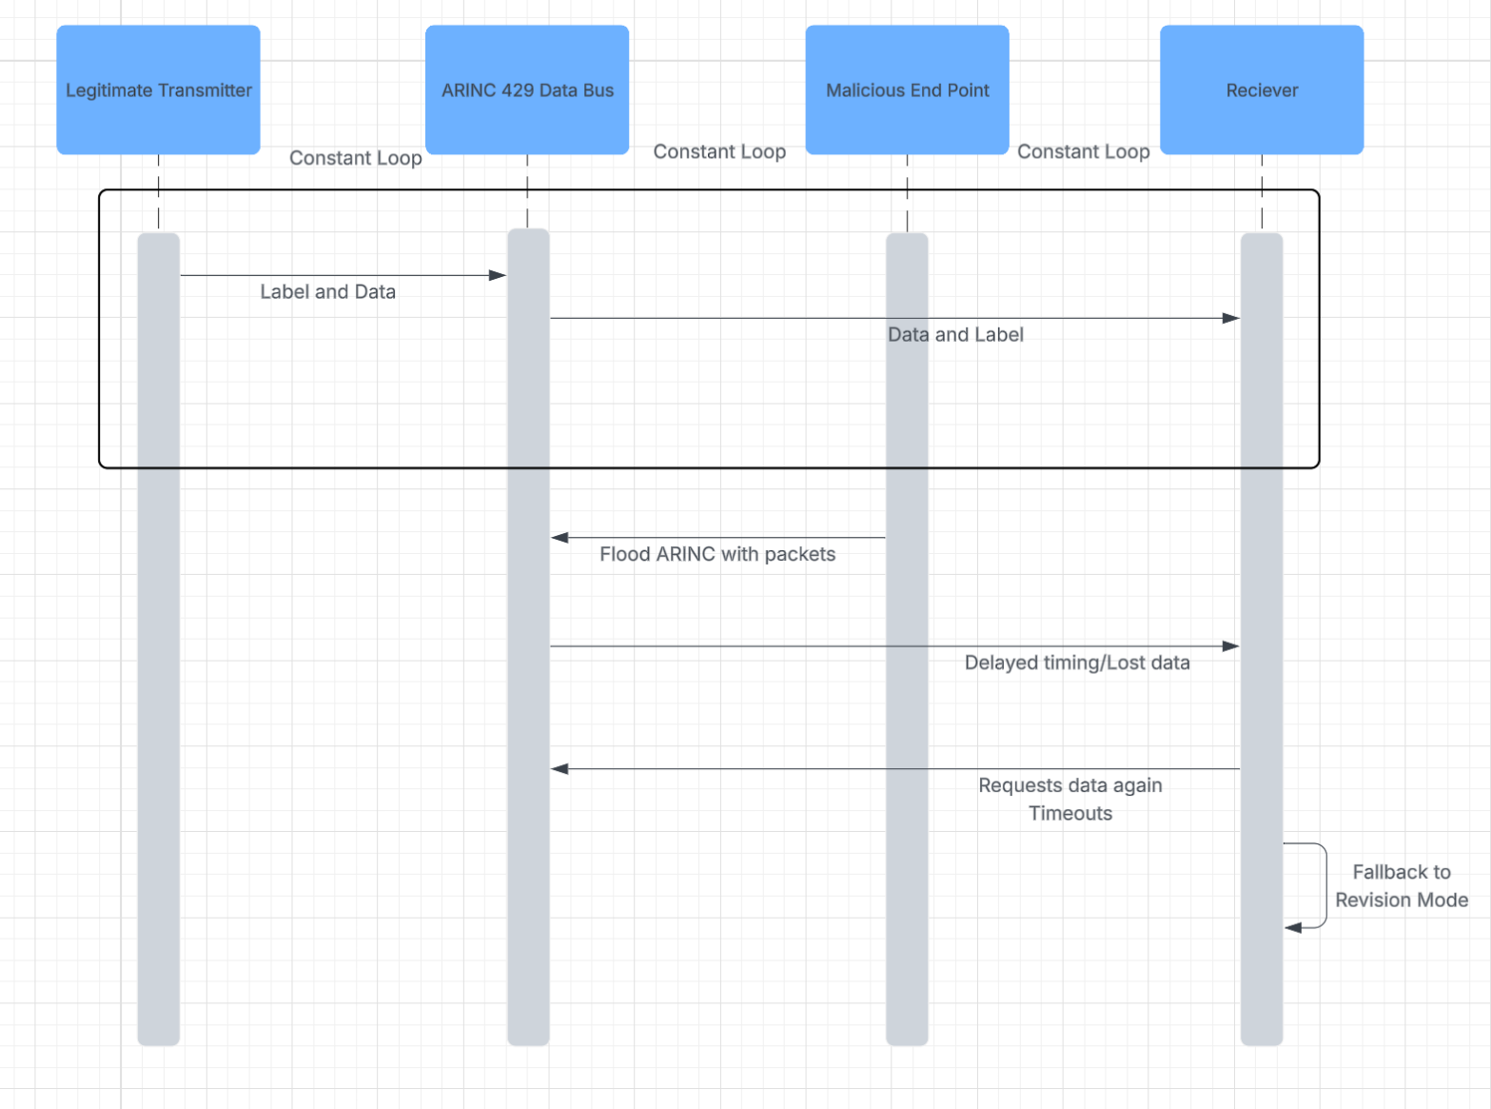
Figure 8: DoS Attack
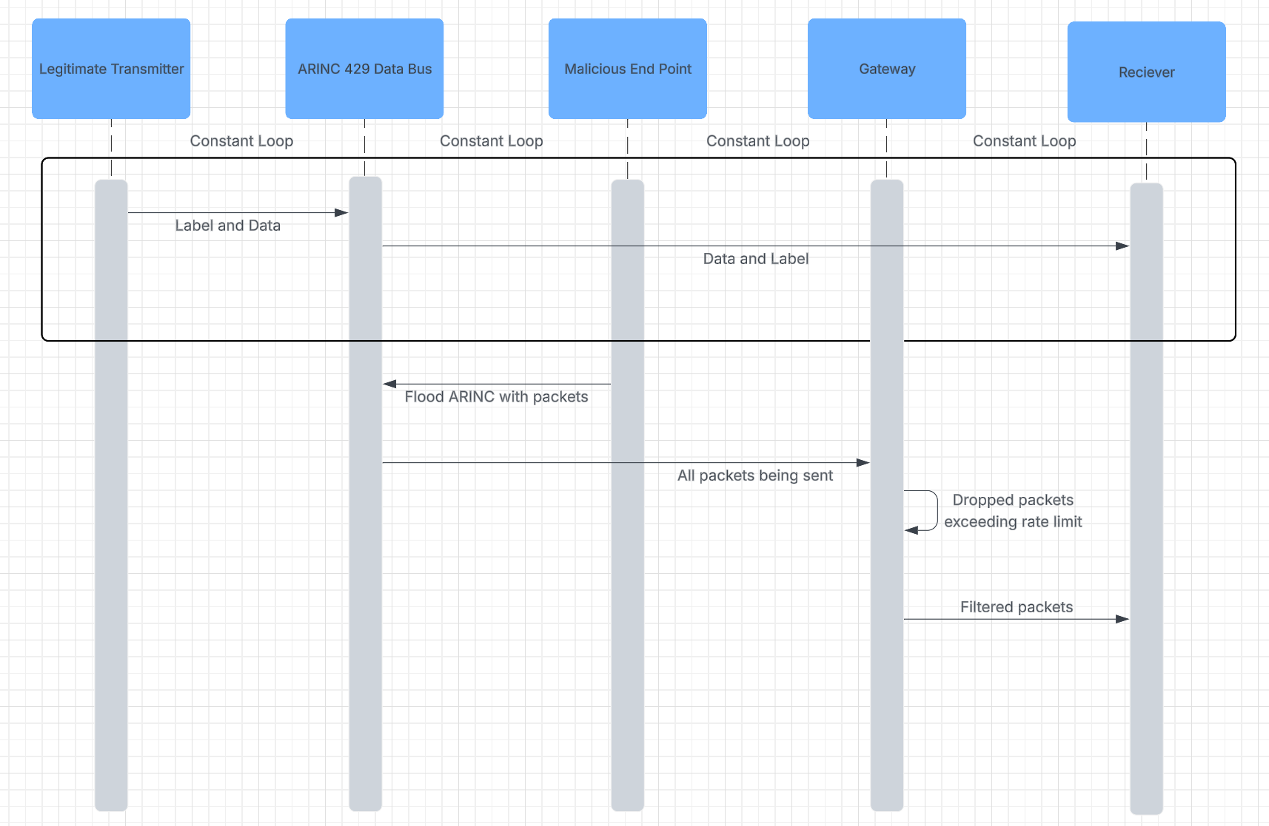
Figure 9: DoS Defense

Security Engineering
There are a plethora of different threat analyses, but for this paper we will go over a general threat analysis of the ARINC 429 data bus using the STRIDE model. We will also be going more in-depth in a threat analysis for our methods of attack using the Dread model, which can be found in Table 1. An attacker can spoof the sending or receiving system of the data bus through physical access or a system specific method. An attacker who has successfully spoofed the sending entity on the data bus, or an attacker who has managed to tap the wire, can alter the data sent over the bus allowing for greater control of the plane's systems.Currently there is no non-repudiation in the airbus system, allowing for attacks to go unmonitored. An attacker who successfully spoofed the receiving end of the data bus or tapped the wire can read packets sent over the data bus and gain potentially sensitive flight information.An attacker who gains access to send messages over the data bus can send many null or junk packets over the data bus potentially creating a bottleneck. An attacker who has the ability to tamper with the frames sent over the bus can alter frames 9 and 10, these bits control what system the frame is being sent to, allowing the attacker to send a frame to a system with higher privilege than originally intended.

 | Denial of Service  (DoS) | Altered Frames (Tampering) | Replay (Spoofing)
Damage | (3) Could cause systems to revert to reversion mode | (3) Can affect all receiving nodes on the same bus | (3) Can affect all receiving nodes on the same bus
Reproducibility | (2) The attacker needs access to the plane in order to carry on with the DoS attack but once they have it the it is easily repeatable | (1) Frame specifications varies by manufacturer | (3) does not require knowledge of data specifications, attack stays the same if the same LRU is compromised each time
Exploitability | (2) Needs physical access or privileged access to the avionics | (1) Requires physical access, custom malware, and knowledge of how receivers interpret data | (2) Requires physical access and custom malware
Affected users | (3) Potential for all passengers to be affected | (3) Potential for all passengers to be affected | (3) Potential for all passengers to be affected
Discoverability | (3) The protocol is public, but the bus architecture, label and data specifications are not public | (2) Knowledge of theoretical attack is easily discoverable due to public protocol information, however label and data specifications are not public | (2) Knowledge of theoretical attack is easily discoverable due to public protocol information, however label and data specifications are not public
Total | 13 (High) | 10 (Medium) | 13 (High)
Table 1: DREAD Model for Attacks

The general use case for the ARINC 429 airbus, according to Figure 2, is a middleman for data transfer internally in the plane. In an interaction with the airbus, it starts with a user or a task scheduler sending data to an input system, after that the input system sends the data through the airbus and the airbus sends it to one of twenty output systems. It is important to note input and output systems can be any system on the plane including other airbus’s. We have identified that an attacker will either attack the data before it gets to the airbus at the input system, or if the attacker has physical access, possibly from being an airline employee, or successfully infiltrates the airbus supply chain they can directly attack the data in transit over the airbus.

Spoofing
ARINC 429 is the primary data bus standard applied in commercial aviation for inter-subsystem communication. The standard is defined by its bit structure; it sends 32-bit words, of which 24 bits carry the actual data and 8 bits are used for designating the data in between. But this simplicity results in a vulnerability in security. The protocol's requirements do not include any built-in methods for verifying message authenticity, maintaining integrity, or ensuring confidentiality.
A spoofing attack/injection directly exploits the lack of authentication. In this attack, a malicious actor with physical or logical access to the ARINC 429 bus can impersonate a legitimate transmitter. Attack vector: The attacker connects a malicious device, like a rogue transmitter or a compromised legitimate unit, to the bus. Attack method: The malicious device listens to the bus to understand the data format and label. It then begins transmitting messages with the same label as a legitimate source but containing malicious data. For example, it could spoof the air data computer and transmit false air speed data. Impact: Since receiving systems have no way to verify the source or integrity of a message, they will process the spoofed data as if it were genuine. This can lead to catastrophic consequences, such as the autopilot executing dangerous maneuvers based on false information. This attack is likely because ARINC 429 is a broadcast protocol on a shared medium with no source identification beyond the data label itself.
To mitigate the spoofing attack, I propose augmenting the ARINC 429 protocol with a cryptographic authentication mechanism. Mechanism: For each critical data word, the transmitting system calculates a MAC using a secret symmetric key shared only with the intended receiver. This MAC is encrypted and the data word's contents. The MAC is then appended to the standard 32-bit ARINC word as a new field. Given the 32-bit limit of a single ARINC word, this would typically require using a second, dedicated ARINC word to transmit the MAC. Process: The receiver, possessing the same shared key, recalculates the MAC upon message receipt. If the assessed MAC matches the received MAC, the message is authenticated, and its integrity is verified. A mismatch indicates a spoofed or corrupted message, which should be rejected by the receiver. Implementation consideration: This defense is not part of the ARINC 429 standard and would require modifications to both transmitting and receiving part. It introduces latency and requires secure key management.

Replay Attack
Even after the HMAC has been added to protocol, stopping attackers from altering the packets to be whatever they want. It is still possible for attackers to send false packets via a replay attack. This attack works as shown in figure 4, where an attacker will listen in on all packets on the incoming bus, and when they observe the action that they desire, they copy that packet and send it repeatedly. This causes the behavior observed by that packet to be performed at the attackers will, potentially causing anything from delays to loss of life.

In industry, the standard method of preventing this type of attack is the use of a NONCE, also referred to as a number only used once. A NONCE is a number generated and appended to the front of a packet, this number is checked by the receiver against a list of used NONCE’s and if it has already been used the packet is denied. This type of defence pairs especially well with HMAC hashing because if the NONCE was in plaintext, a clever attacker could recognise and change the nonce, but with HMAC the attacker would first need to find the key used to hash the packet. The HMAC hashing and NONCE work together to make each other more secure, and makes it significantly more difficult for attackers to perform spoofing or tampering related attacks. There are many methods to choose what the NONCE should be, but in our example, we decided to choose a simple counter style NONCE. This was chosen mainly in order to keep the system as quick as possible, because it is important for the plane to transmit data at a quick speed. Additionally it was chosen over timestamp style NONCE because it is possible that with blazing quick transmission speed that two legitimate messages are sent with the same timestamp.

With the implementation of NONCE and HMAC together, in order for an attacker to perform any tampering or spoofing related attack, the attacker would need to first tap into the bus and read all data being transmitted. Then the attacker would need to find the HMAC key, which would prove to be extremely difficult given the time he would need to test all the keys and due to the fact that the attacker would not know what a plaintext message looks like. Then finally, the attacker would need to identify the NONCE algorithm and ensure that they increment it correctly each time they would like to send a packet. Although this is a possible sequence of events, it would be extremely difficult and time consuming, and we believe it is a strong enough deterrent to stop this style of attack.

DoS Attack
The ARINC 429 databus is susceptible to a variety of different attacks as shown in the past few paragraphs, like a spoofing attack and replay attack, but in this section we will be talking about a different attack vector, DoS attack. The outline for a basic DoS attack is to have an end-point connecting to the databus and can range from flood the traffic with invalid or fake packets to the point where it slows the system down to the point that it is unusable, or to deny 1 packet that is sent. We can see the outline for how a DoS attack would work within the ARNIC 429 system in Figure 8. Where the malicious end point gains access to the databus and sends packets to the databus, which then they forward to the receiver but since the shear number of packets is massive, the databus messes up the timing of the packets which then the receiver will request a send again of packets until eventually it doesn’t get a return or is overwhelmed.

Currently there are no protections from a DoS attack, only a reactionary measure where if the receiver is unable to communicate with the databus and after not receiving anything after the request or continuous improper timing, the databus system reverts to revision mode. But, we do not want this to happen since within that short time, critical flight data could be compromised so for our defense against a DoS attack, we propose to implement a gateway between the databus and the receiver, which the flow of information is outlined in Figure 9. Looking at Figure 9, we can see that once the attacker floods the databus with packets, instead of the databus forwarding them to the receiver, they go through a gateway that enforces rate limits per transmitter which would drop all packets coming from that transmitter. This gateway would also create a buffer so that all the packets being sent through have the correct timings. Despite the required timing for airplanes to be very quick, I believe that the gateway would be able to keep up with the data rates. Once the packets go through the gateway, they get forwarded to the receiver which then processes the packets.

Alignment with Industry Standards
Aviation systems and aircraft components inherently require a physical or logical connection for any potential attack. While the security around these elements is robust and not easily accessible in real-world scenarios, our project has created and implemented a realistic simulation to demonstrate credible attack vectors and corresponding defensive measures. Though the industry standard for ARINC 429 data bus is directly informed by and aligns with the two key aviation industry standards provided for our project: DO-178C, which governs software safety, and DO-326A, which addresses airworthiness security. We looked into the standards applying to our threat model and proposed solutions. For the attack examples like spoofing, DoS, and replay attacks, the DO-326A standard requires a structured threat analysis and risk assessment (TARA). Yes, our initial threat analysis in the proposal document explicitly identifies spoofing and DoS as primary threat vectors, and a replay attack is a logical extension of our tampering and spoofing categories. This formal identification of threats against specific aircraft system components, such as the data bus, is the foundational first step required by the industry security process to be secured.
To defend against these threats, we proposed a cryptographic authentication mechanism, such as a message authentication code (MAC), to validate every message on the bus, and this mechanism directly aligned with the security objectives of DO-326A. The standard calls for implementing technical security measures to ensure data integrity and authenticity, which is exactly the purpose of our cryptographic gateway. Furthermore, our design consideration for the gateway's processing speed, “sub-1ms latency,” shows we are holding to the core principles of DO-178C. This standard requires that safety critical software, which our gateway would become, exhibits predictable, verifiable, and reliable performance so it does not interfere with the real-time operation of essential flight systems.
Therefore, our proposal demonstrates a basic representation of industry regulation and technical implementation. We started with the required security process to define the problem, and we are proposing a solution of cryptographic validation that meets the security objectives while being consciously designed within the stringent software safety framework (DO-178C). This alignment proves our project is not just a theoretical cybersecurity exercise but a structured investigation into a practical and standards-compliant method for hardening a critical aviation system. Our work aligns directly into the processes of aviation security enhancement for modern or legacy aircraft.

Implementation and Validation

Tools, Languages, and Libraries used
Our team used no external tools to conduct this security audit and wrote all code in python. The Libraries we used are as listed; can, time, random, haslib, hmac, struct, socket, and, json

Spoofing DEMO
Note: this particular spoofing demonstrates how an attacker sends a fake air speed to display to the pilot (regular air speed for a commercial airplane, 475 -500knots).
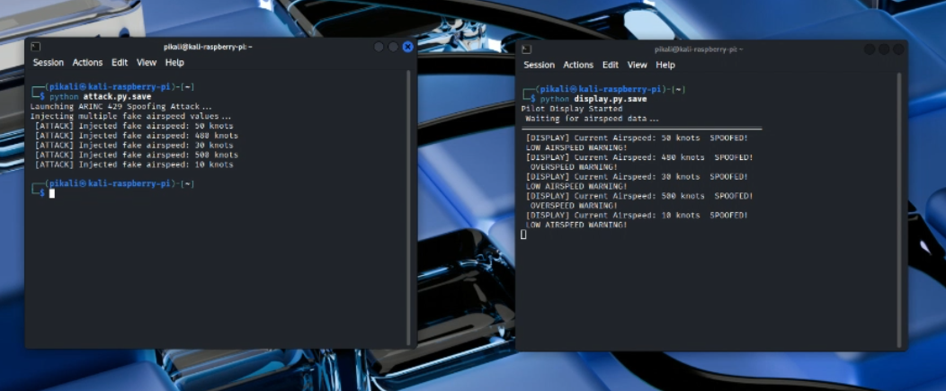
Figure 10: Spoofing Attack Demo
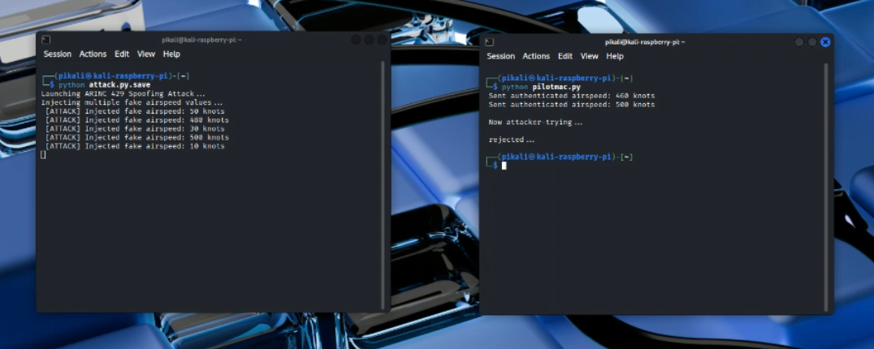
Figure 11: Spoofing Defense Demo
Validation
In regular ARINC 429 communication, someone can sneak an attack right onto the data bus. A rogue transmitter just jumps in, sends a message with the same label as the real ones, and no one notices. The receiver can’t tell if that package is fake or not—it just takes it in and processes the info. That’s how the whole system ends up compromised.
So, the proposed cryptographic authentication defense prevents spoofing attacks by creating a layer that rules them out. The defense works by requiring a legitimate transmitter to generate a MAC using the shared secret key and appending it to the message. The receiver validates the MAC (fake or no MAC or real) before processing the data, then accepts real data or rejects malicious data, and alerts the receiver.

Replay DEMO and validation
The experimentation and validation of the replay attack in defense consisted of messages being sent to the pilot interface that displays important information to the pilot, the information is sent from the angle of attack sensors and the flight management system. The attack happens when the malicious flight management system runs and captures a “Plain is moving down” packet from the angle of attack. Then the malicious flight management system replays the packet multiple times and it causes the pilot interface to display that the plane is going down, causing the pilot to think the plane is crashing. This process is seen in the figure below. You can see that the Malicious FMS sends many packets in a replay flood style, and consequently the pilot interface believes that the angle of attack is sending it packets saying that the plain is going down due to the packets label and SSD (the only form of authentication on a frame) being copied by the malicious flight management system.
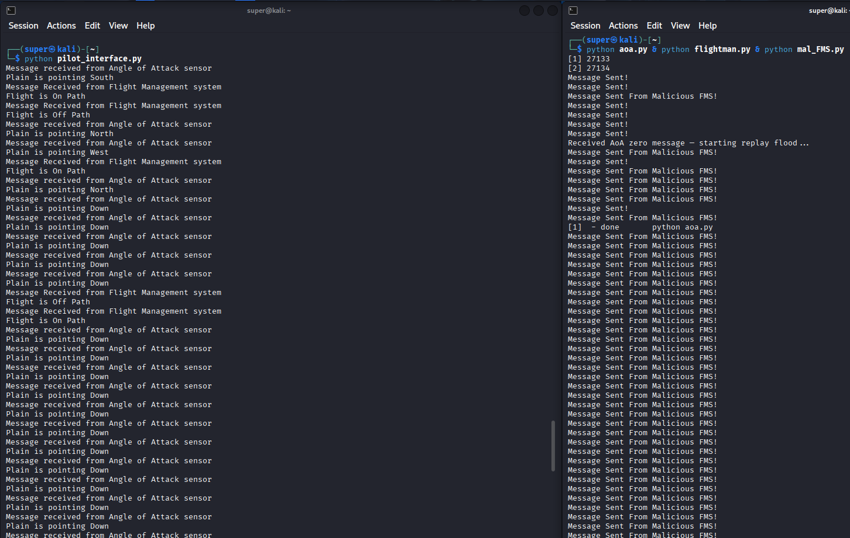
Figure 12: Replay Attack Demo
The defense was tested by running a slightly modified version of the previous attack, the only difference being that the malicious flight management system was modified to read forty bit frames, and now it always replays the eighth frame it reads instead of the down packet specifically. This change was made because it was impossible to specifically identify the “Down” frame due to the HMAC hashing, if an attacker wanted to do this, they would need to manually observe how each packet affects the plains behavior. The new code is labeled with “secure” in the front as seen in the figure below, the main difference being each frame is hashed using the HMAC encryption scheme explained in the “Spoofing” attack section of this report,and that the first 8 bits of the data field is now considered to be a nonce. This NONCE is incremented each time a message is sent and then verified if it is the correct expected nonce by the receiver. The NONCE is determined by a counter that increments each time a message is sent or received.There is now additionally an 8 bit field added to the front to serve as the HMAC tag, allowing the receiver to identify that it is authenticated. The NONCE is added to the frame before it is hashed by the HMAC algorithm, making it impossible for attackers to observe the NONCE unless it is decrypted. The modified attack was played alongside the defence and the packets were determined to be dropped by the flight management system due to an unexpected nonce as shown in the figure below.

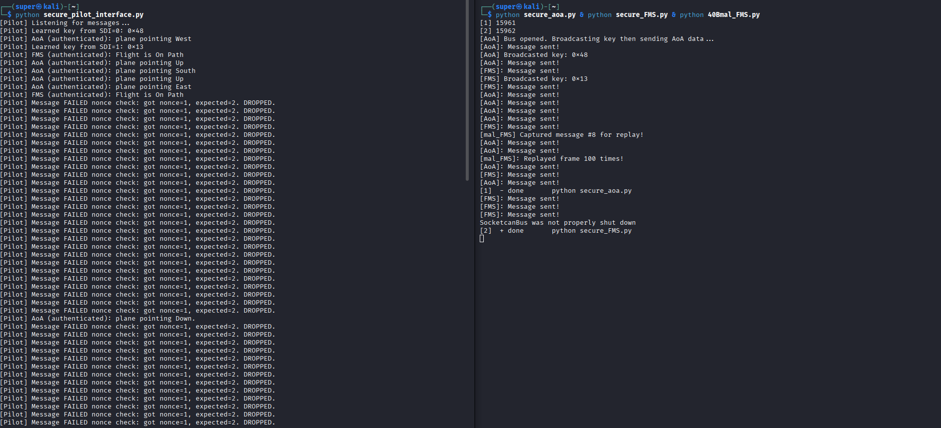
Figure 13: Replay Defense Demo

DoS DEMO and validation
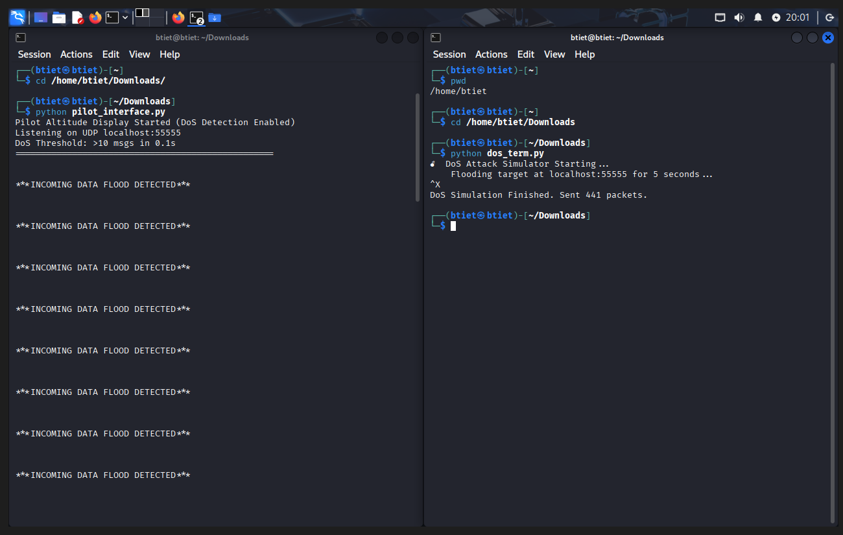
Figure 14: DoS Attack Demo
The DoS attack happens when the flight display system displays a message “INCOMING DATA FLOOD DETECTED” packet from the dos_term. The malicious end point continues to flood the transmission with the same message, not allowing any sort of other packets to be sent. The flight information system is unable to show accurate data which leaves the pilots blind to all of the parameters of flight, like their trajectory. Which is shown in Figure 14, where the malicious endpoint is constantly sending a flood of data.

Conclusion and Future Work
Despite the challenges we faced in this project, such as, not being able to physically use the ARINC 429 databus or the licensed software, and sort of getting lost in how to approach the data bus. We have come together and were able to simulate the communication between the transmitter, databus, and receiver using the CAN FD software. We also were able to each separately come up with an attack vector and a potential defense for said attack vector. With all of them though, the assumption is that you have physical access to the wire, but we decided on performing a spoofing, replay, and DoS attack on the databus, with defenses of MAC signatures for verification and authentication, NONCE to ensure there is no replay, active monitoring, and a gateway that enforces rate limits and buffer for timings. A few challenges with these defenses and overall databus is the need to flash the key to each system, checking and monitoring people with access to the bus, and identifying breaches during operations. This project gave us all practical experience with what a project could look like in the work force and what it would look like to work in a team to solve problems and try to secure said problems. So overall, it was a great experience for us all to go through and learn from to have practical experience.

References
IEEE Reference Guide, IEEE Publication Operations, 445 Hoes Lane, Piscataway, NJ, November 29th, 2023. [Online]. Available: https://journals.ieeeauthorcenter.ieee.org/wp-content/uploads/sites/7/IEEE_Reference_Guide.pdf
B. Waldmann. ARINC 429 Tutorial, v2.2. (2019). Accessed: September 12th, 2025. [Online]. Available: https://www.aim-online.com/wp-content/uploads/2019/07/aim-tutorial-oview429-190712-u.pdf
C.James M. Turner, Deputy Director FIPS PUB 198-1 FEDERAL INFORMATION PROCESSING STANDARDS PUBLICATION (July 2008) The Keyed-Hash Message Authentication Code (HMAC) [Online]. Available:
https://nvlpubs.nist.gov/nistpubs/fips/nist.fips.198-1.pdf
D.AC 119-1A - Operational Authorization of Aircraft Network Security Program September 28th,2023 . [Online]. Available:
https://www.faa.gov/regulations_policies/advisory_circulars/index.cfm/go/document.information/documentID/1042159
E. Wikipedia contributors. (2025, November 8). ARINC 429. Wikipedia. [Online]. Available: https://en.wikipedia.org/wiki/ARINC_429
F.DO-178C Software compliance for aerospace &defense [Online]. Available:
https://alm.parasoft.com/hubfs/ebook-DO-178C-Software-Compliance-Aerospace-Defense.pdf G.DO-326A / ED-202A Intro to Aviation Cyber-Security White Paper [Online]. Available very limited: https://afuzion.com/do-326a-ed-202a-aviation-cyber-security/

